Eligibility Requirements
To be eligible for a property tax deduction or property tax credit in NJ:
♦ You must have been domiciled and maintained a principal residence as a homeowner or tenant in New Jersey during the tax year; and
♦ Your principal residence, whether owned or rented, must be subject to local property taxes, and property taxes must have been paid on that residence either as actual property taxes or through rent; and
♦ Your rented dwelling must have its own separate kitchen and bath facilities; and
♦ Your income on Line 28 is more than the filing threshold amount for your filing status, or you (and/or your spouse/civil union partner if filing jointly) were 65 or older or blind or disabled on the last day of the tax year. Taxpayers with gross income of $20,000 or less ($10,000 if filing status is single or married/CU partner, filing separate return) are eligible for a property tax credit only if they were 65 or older or blind or disabled on December 31 of the tax year.

Note:
- P.I.L.O.T. (Payment In Lieu Of Taxes) properties do NOT pay local property taxes
- Section 8 (or any other rent subsidy) does NOT disqualify one for the Deduction/Credit – You must still check if the landlord pays taxes. The Deduction/Credit is, however, only based on (18% of) the actual rent paid after any subsidy.

There are certain complexes that are not subject to property taxes. How do you determine if a property is subject to property taxes?

Properties with the "property class code" beginning with 15 (it can be 15A, 15B, etc.) – are tax-exempt properties and don't pay taxes. If an apartment building does pay taxes, the property Class Code is 4-something. Therefore, any property with a 15 in the class code does not pay taxes and therefore taxpayers who live in these facilities are not eligible for the NJ property tax deduction or credit.

Use the “NJ Property Tax List Search” on the left side of the preparer’s page to check any property.

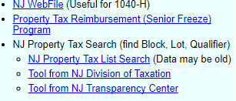

On the next page are examples of two properties that do not pay property taxes and therefore the tenants who live in these buildings are not eligible for the NJ property tax credit or deduction.

Listing for Cooks Pond Senior Housing, Denville

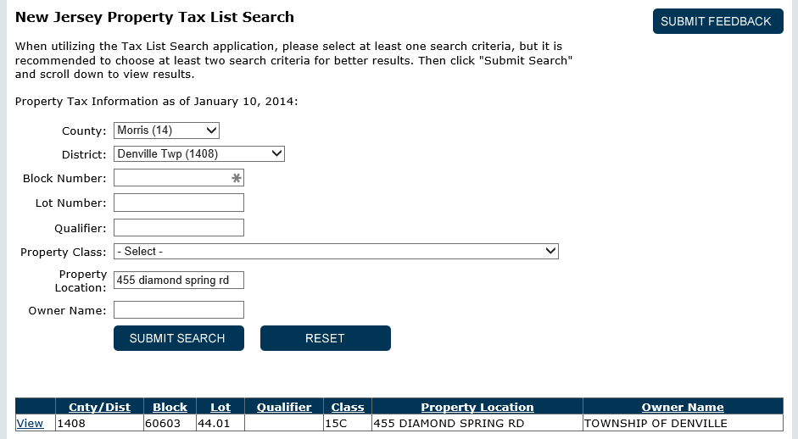
Property class codes with the number 15 are tax exempt
For more details about the property, click “view”

Listing for Centennial Courts, Wharton

